WEB Quest Photography Theory component

Items highlighted in yellow are tasks for you to complete
Items in Blue italics are help tips
You should find more links on the Internet to help you answer questions
Questions are numbered and may be highlighted = answer where you see this Answer

WBQ115 Web Quest – Photography Theory component
Complete the following Web Quest

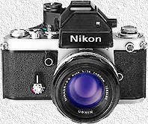
You will need to rely on the internet, textbooks and your teacher for assistance. Copy and paste the questions below into a new word-processor, publisher or any other program you feel appropriate, then add your answers, applying the presentation conventions required in this course.

1. Provide an explanation of the following two photographic concepts or terms;
1.1 Shutter speed
http://www.mir.com.my/rb/photography/fototech/apershutter/shutter.htm

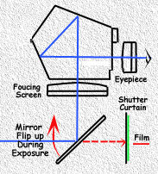

What is shutter speed ? The aperture diaphragm of a lens (bigger or smaller values) AND timing (open and close) of the camera's shutter curtain - BOTH perform the tasks of regulating the amount of light entering the camera and expose onto the film. The shutter speed scales engraved on the shutter speed dial of conventional camera bodies with a shutter speed ring OR via some flickering digital numerals on the LCD screen like: 1/8000, 1/4000, 1/1000, 1/500, 1/250, 1/125, 1/60, 1/30, 1/15, 1/8, 1/4, 1/2, 1 or -1, -2 etc. are essentially indicators of the duration (timing) at which the shutter curtain opens up and closes during an exposure process.
A 1/125 setting means the shutter curtain open and close within one hundred and twenty five of a second while 1 means an one full-second the shutter opens up during exposure to absorb the available light source onto the film to form an exposure. 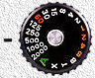

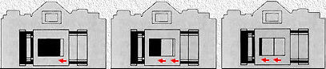

The shutter speed dial provide the selection of shutter speeds, and indicates the timing of the shutter open and closes. A fast shutter speed such as 1/500 sec will close faster than, say 1/2 sec exposure time. In this case, the shutter curtain will close very fast and thus resulting in less light entering the film. Illustration used here is a older horizontal shutter design

1.2 Aperture
http://en.wikipedia.org/wiki/Aperture
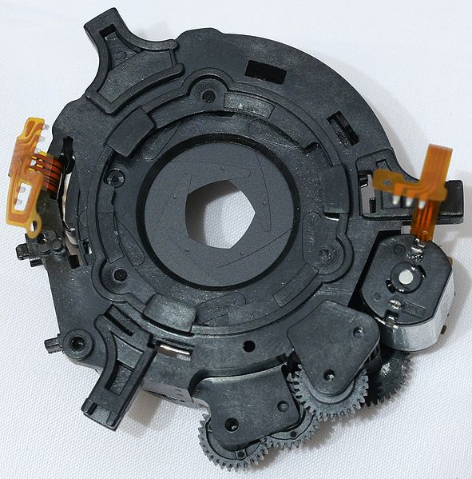
In optics, an aperture is a hole or an opening through which light travels. More specifically, the aperture of an optical system is the opening that determines the cone angle of a bundle of rays that come to a focus in the image plane. The aperture determines how collimated the admitted rays are, which is of great importance for the appearance at the image plane. If an aperture is narrow, then highly collimated rays are admitted, resulting in a sharp focus at the image plane. If an aperture is wide, then un-collimated rays are admitted, resulting in a sharp focus only for rays with a certain focal length. This means that a wide aperture results in an image that is sharp around what the lens is focusing on and blurred otherwise. The aperture also determines how many of the incoming rays are actually admitted and thus how much light reaches the image plane (the narrower the aperture, the darker the image for a given exposure time).
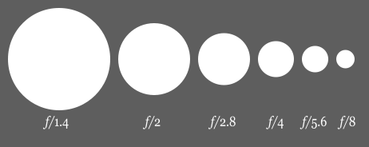

2. While not as significant with your small portable point and shoot digital cameras common today, the concept of film speed (ISO or ASA or DIN) is still important to understand. Explain this concept.
http://www.digital-photography-school.com/iso-settings

A lens you attach to a digital camera is often differentiated from other lenses by its Focal length rating such as a 35mm lens, 50mm lens, 70mm lens, etc. This enables you to have a Wide angle lens or a Zoom lens and others in between. Without getting into the Physics or Mathematics involved,
3. Insert a picture to provide a basic definition of Focal length. Provide example pictures (with labels or annotation pointing out what they are examples of). 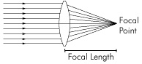
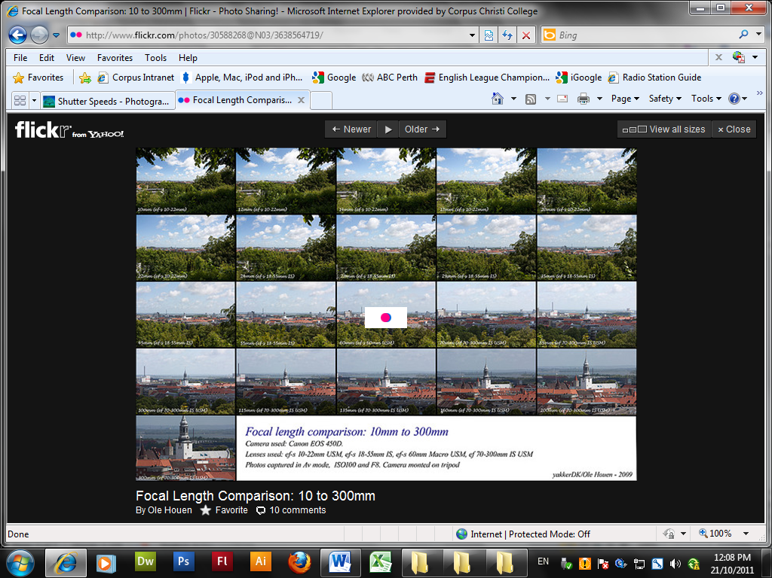
http://www.photoxels.com/tutorial_focal_length.html

4. Discuss megapixels – what do they mean to the average photographer? 10 megapixel image contains approximately how many pixels?
http://www.digital-slr-guide.com/define-megapixels.html

5. A second consequence of the aperture setting of a lens, is on the Depth of field in focus. With example pictures demonstrate the effect of different aperture settings on the Depth of field in focus.
Show an example of shallow depth of field and one of Large Depth of Field
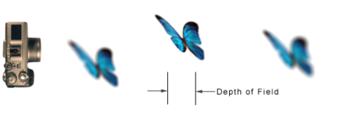
http://www.secondpicture.com/tutorials/photography/meaning_of_depth_of_field.html

6. Analogue cameras used film to record photos, where as digital cameras use a CCD. In simplistic terms (without going into the physics or high level electronics of this device), how does the CCD work?
http://electronics.howstuffworks.com/cameras-photography/digital/digital-camera2.htm

7. What does CCD and CMOS stand for?
http://electronics.howstuffworks.com/cameras-photography/digital/digital-camera2.htm
A charge-coupled device (CCD) is a light-sensitive integrated circuit that stores and displays the data for an image in such a way that each pixel (picture element) in the image is converted into an electical charge the intensity of which is related to a color in the color spectrum. For a system supporting 65,535 colors, there will be a separate value for each color that can be stored and recovered. CCDs are now commonly included in digital still and video cameras.

8. Storing digital pictures
8.1 A digital picture uses pixels to record an image and a computer screen uses the same pixels to display the image. What is a pixel?
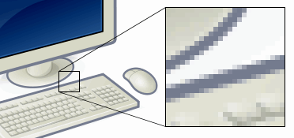
In digital imaging, a pixel, or pel^{[1]}, (picture element^{[2]}) is a single point in a raster image, or the smallest addressable screen element in a display device; it is the smallest unit of picture that can be represented or controlled.
Each pixel has its own address. The address of a pixel corresponds to its coordinates. Pixels are normally arranged in a two-dimensional grid, and are often represented using dots or squares. Each pixel is a sample of an original image; more samples typically provide more accurate representations of the original. The intensity of each pixel is variable. In color image systems, a color is typically represented by three or four component intensities such as red, green, and blue, or cyan, magenta, yellow, and black.

8.2 In Australia we use RGB (red, green blue) combinations as an artist would mix different primary colour paints to obtain the shades of colours we want with each pixel. How is this achieved within each pixel
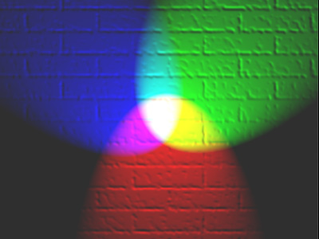
http://en.wikipedia.org/wiki/File:RGB_illumination.jpg
The RGB color model is an additive color model in which red, green, and blue light is added together in various ways to reproduce a broad array of colors. The name of the model comes from the initials of the three additive primary colors, red, green, and blue.
The main purpose of the RGB color model is for the sensing, representation, and display of images in electronic systems, such as televisions and computers, though it has also been used in conventional photography. Before the electronic age, the RGB color model already had a solid theory behind it, based in human perception of colors.

8.3 How much (intensity) of each of the three RGB colours is recorded as a separate binary number for each. Binary numbers are made up of bits. The more bits used (made available for this), the bigger the number that can be recorded. The bigger the number used, the more colours and shades of colours that can be used in a digital picture.
a) In this context and in your own words how would a 16 bit picture be better than an 8 bit picture?
b) How would the storage size requirements be different between a 16 bit and an 8 bit picture? Why

8.4 People will often rate the quality of a digital camera or a digital picture according to its "Mega Pixels". Provide a clear explanation of what a mega pixel is and why people may rate the quality of a digital camera or a digital picture in this way?

8.5 If I had a digital picture with a resolution of 1920×1200, what would be its mega pixels rating?

About 10.5Mp

Number of Megapixels | Acceptable Print Size (Inches)
2.0 | 4 x 6 [standard]
3.0 | 5 x 7
4.0 | 8 x 10
5.0 | 8 x 12
6.0 | 9 x 12
8.0 | 11 x 14
10.0 | 12 x 16
12.0 | 16 x 20
14.0 | 18 x 24

Digital cameras use photosensitive electronics, either charge-coupled device (CCD) or complementary metal–oxide–semiconductor (CMOS) image sensors, consisting of a large number of single sensor elements, each of which records a measured intensity level.

8.6 There are many different picture or image file formats, TIFF and JPEG are two examples. Point out some characteristics or advantages and disadvantages of these two examples.

Image file formats are standardized means of organizing and storing digital images

8.7 Some professional photographers use RAW image format rather than any of the typical image file formats, even though they are much bigger in file size. Why?
A camera raw image file contains minimally processed data from the image sensor of either a digital camera, image scanner, or motion picture film scanner.

9. Displaying digital pictures
9.1 One way to judge the quality of a computer screen is by its PPI (Pixels Per Inch). Explain why would a computer screen with more pixels per inch be considered better?
9.2 What is DPI (Dots Per Inch) and when is this term used?

9.3 What is the definition of the following digital picture editing terms;
a) Crop | Trim off Edges
b) Cut | Remove completely
c) Resizing | Change the size of the original
d) Enhancing | Improve the quality of the original

What advice would you give concerning environmental and/or disposal and/or safe handling and/or Recycling concerns with digital cameras or the batteries they use?
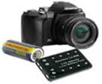
10. Explain at least four different types of camera battery and how should we dispose them.
http://www.rpc.com.au/products/services/faq-info/batterydisposal.html

- Alkaline batteries - contain potassium hydroxide, and mercury
- Zinc-Carbon batteries (ordinary D cell flashlight battery) Contain varying amounts of mercury and potassium hydroxide and Lead
- Silver Oxide batteries- contain potassium hydroxide concentration, silver oxide and mercury
- Mercuric Oxide batteries –contain mercury, mercuric oxide, potassium hydroxide and/or sodium hydroxide

Course: | Certificate II in Information Technology  Cert II  IT
Unit: | 14 ICPMM321B Capture a digital image 30
Title: | 14.01 Basic Photography
Class: | C2CIT
Area: | Technology & Enterprise
Cert IV Teacher | Mr P Faulks

ASSESSOR FEEDBACK FORM
Student Name:
Assessment Date/Due |  | Assessor’s Name: | Peter J Faulks
Training Package: | ICA05
Qualification: | ICA20105 Certificate II in Information Technology

FEEDBACK FOR FUTURE ACTION
Overall performance, gaps and feedback:

Assessment Record | Satisfactorily Completed
Task 1: Practical Activities | Yes | No
Task 2: Written Questions | Yes | No
Task 3: Observation | Yes | No

Is a reassessment required? Circle  Date of Reassessment if applicable: _____________________ | Satisfactorily Completed
   | Yes | No
Task 1: Practical Activities | Yes | No
Task 2: Written Questions | Yes | No
Task 3: Observation | Yes | No

Assessment of Competency completed: _____/_____/_____

Outcome: (Tick)
Competent |  | Not yet competent

Candidate Signature: | Date:
Assessor Signature: | Date:

